
DFD and TABLE
on
HOSTOHAVEN
BACHELOR OF COMPUTER APPLICATIONS
Of
MAHATMA GANDHI UNIVERSITY, KOTTAYAM
By
SANIYA MOL B
Register No: 230021080922

DEPARTMENT OF COMPUTER SCIENCE
2023-2026

Submitted on,
14-07-2026

CONTEXT LEVEL DFD: HOSTOHAVEN
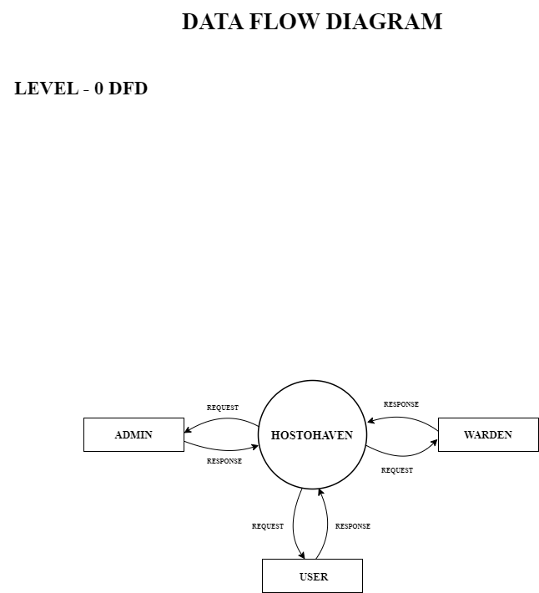
LEVEL 1 DFD: HOSTOHAVEN - ADMIN

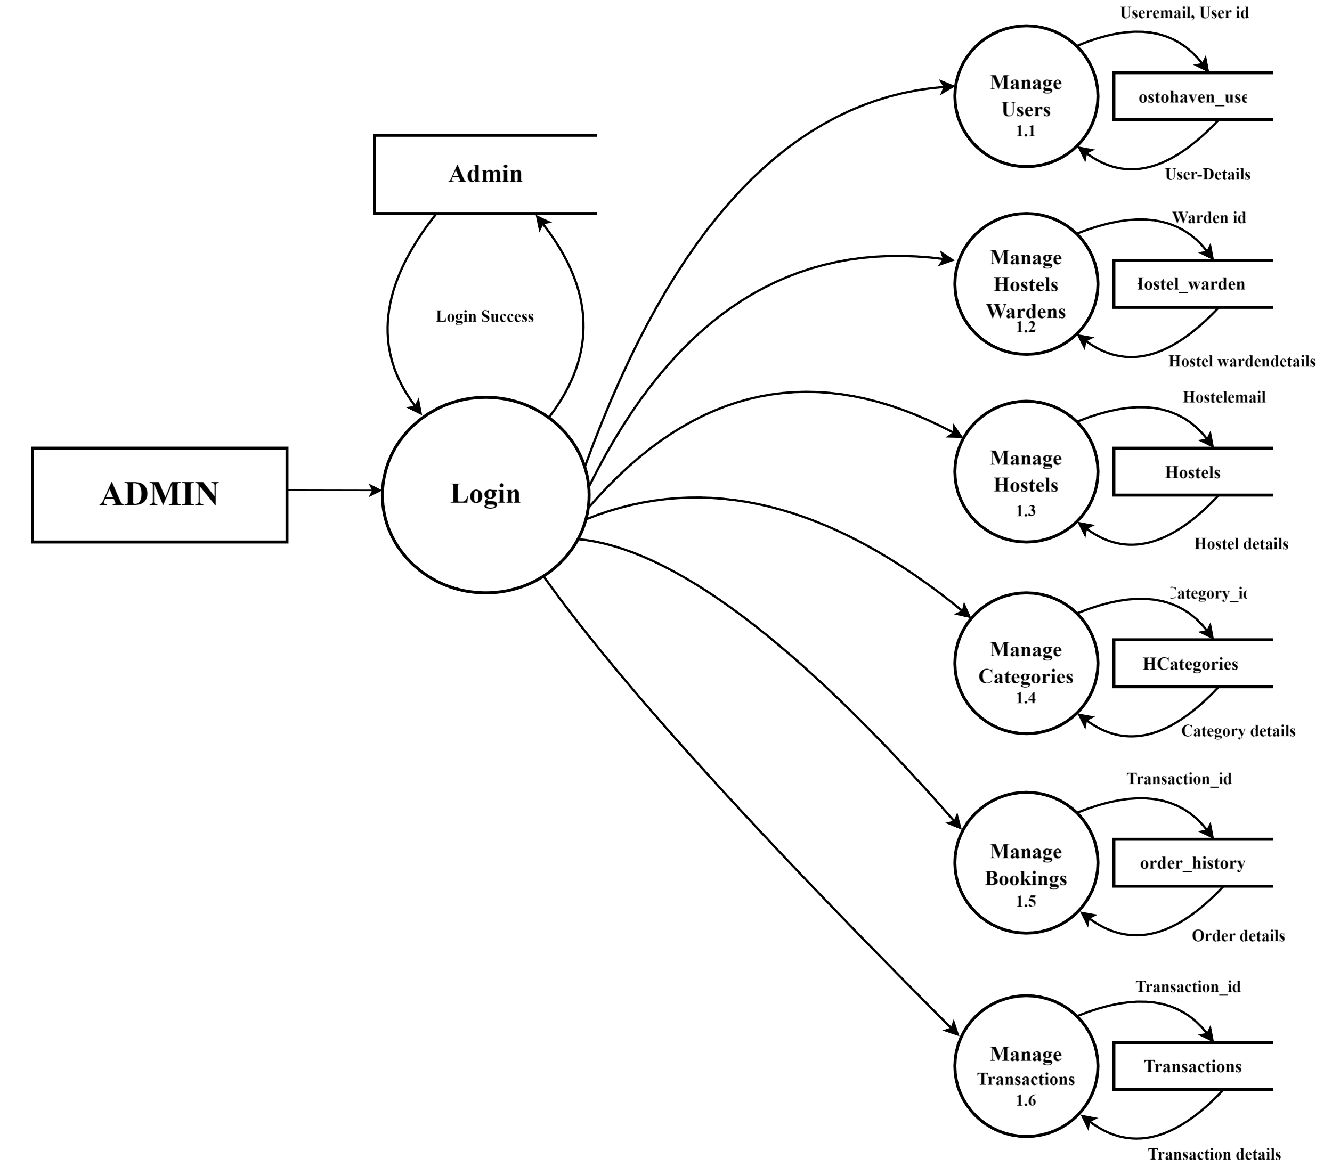

LEVEL 1 DFD: HOSTOHAVEN - WARDEN
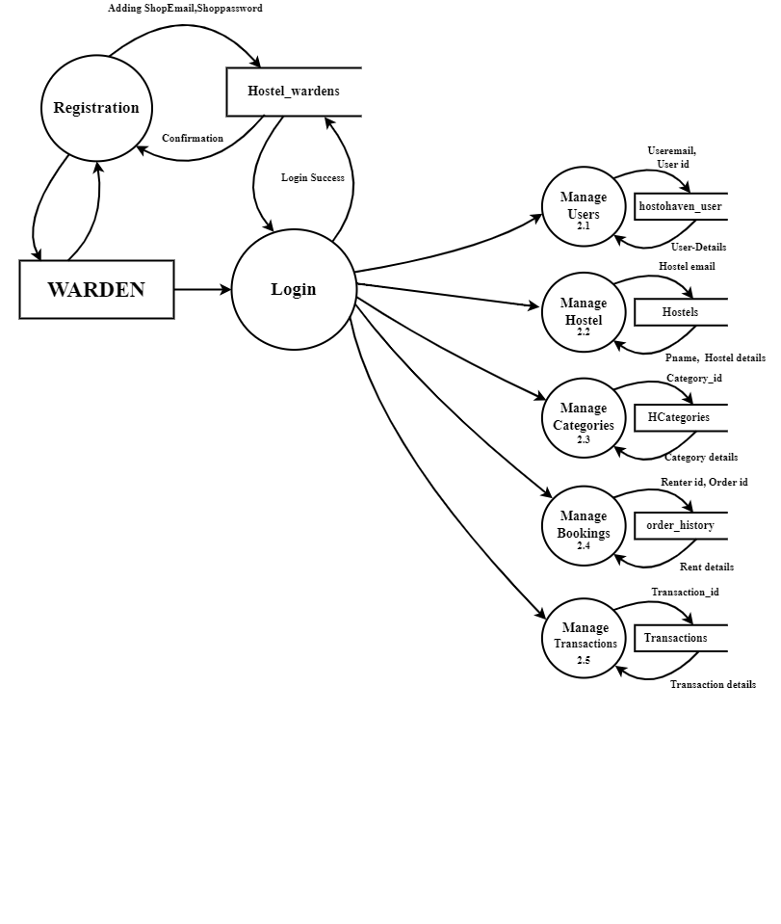

LEVEL 1 DFD: HOSTOHAVEN - USER

